Precision Agriculture Laboratory

Weekly Report

Your Project Title | Real-time Automated Strawberry Yield Prediction System
Report Period | From: 10.28.2026 To: 11.10.2026
Your Name | Jing
Reporting Date | 11.10.2026

Research activities last week
- Revised and submitted the dissertation.
- Completed processing the canopy data, calculated plant roundness, and redeveloped the yield-prediction models using the 2324 and 2526 seasons.
- Handed over the use of ASTIR to Zekun and completed functional testing.
- Checked the field
- Scheduled the date and travel for a visit to the Tampa commercial field. Tested ABV. No issues were observed in the current test.
Problems encountered
- NA
Plan for next week
- Test ABV in the Tampa commercial field, collect field data, and analyze the resulting measurements and system performance.
- My parents are coming to US to visit me.

Yield model development: canopy, roundness and field counts
Reprocessed canopy mask measurements and plant roundness in the 2324 and 2526 strawberry seasons, aligned them with manual flower and fruit counts and observed harvest yield, and evaluated future-yield prediction at one, two and three weeks.
Compared 12 predictive models and six feature sets using manual and YOLO counts in both season-transfer directions and chronological within-season evaluations. Model performance varied by season, forecast horizon and counting source.
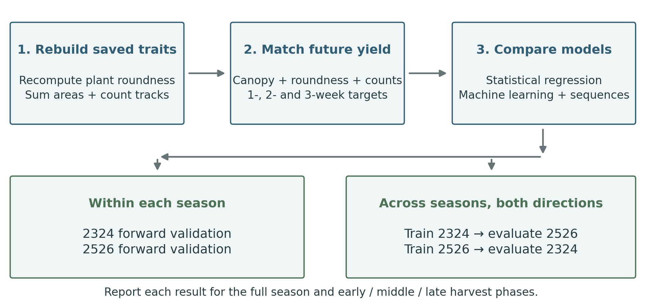
Main findings
Across the available setting–horizon comparisons, Lag random forest with all six features had the lowest average MAE rank among 72 model–input combinations (13.77 out of 72). Individual results vary by evaluation setting. The full comparison follows.

1. Data and measurement
The analysis uses the 2324 and 2526 seasons. Plant roundness was recalculated as Roundnessᵢ = 4πAᵢ/Pᵢ², where Aᵢ is plant mask area and Pᵢ is the complete contour perimeter, including holes. Plot roundness is the mean across retained plants. Canopy size is the sum of their mask areas. The source processing contains 13,353 plant records and 862 plot-dates.
The 2324 YOLO counts came from image-derived detection summaries. The 2526 FL, G, W and P counts were rerun from the original RGB images with the five-class YOLO detector and linked to tracked plant boxes. All 504 available plot-dates completed. Manual counts came from the 2324 field CSV files and the 2526 check-in workbook. FL denotes flower, G green, W white, P pink and R mature red fruit. R is reported descriptively and excluded from every prediction model because it is already mature fruit.
A whole visit date was excluded when fewer than 32 of 40 plots had complete image, manual and YOLO features, or when retained tracks exceeded twice the planted number. Remaining incomplete plot rows were removed. The matched dataset contains 318 plot-dates across eight 2324 dates and 439 across eleven 2526 dates. The 2526 January 12 visit had only 24 image plots. February 23 had a tracking anomaly. Three blank-count visits and two later visits lacked matching images.
Season | Matched plot-dates | Visit dates | Median retained plants
2324 | 318 | 8 | 20
2526 | 439 | 11 | 9
Note. A plot-date is one plot on one image visit. Retained plants are tracked masks used for canopy measurement and quality control. They are not prediction inputs.
Conclusion: Both counting sources and image features are available on the same 757 retained plot-dates. No blank count or yield was replaced with a numerical value.

2. Feature distributions and count agreement
Mean canopy size is 1.76 million pixels per plot in 2324 and 0.15 million in 2526. Planted plants declined from about 20 to 10 per plot, and median retained tracks declined from 20 to 9. Mean mask area per retained track was also about five times larger in 2324. Plant number explains part of the canopy difference. Image scale and segmentation also contribute. Pixel area is not a calibrated physical area.
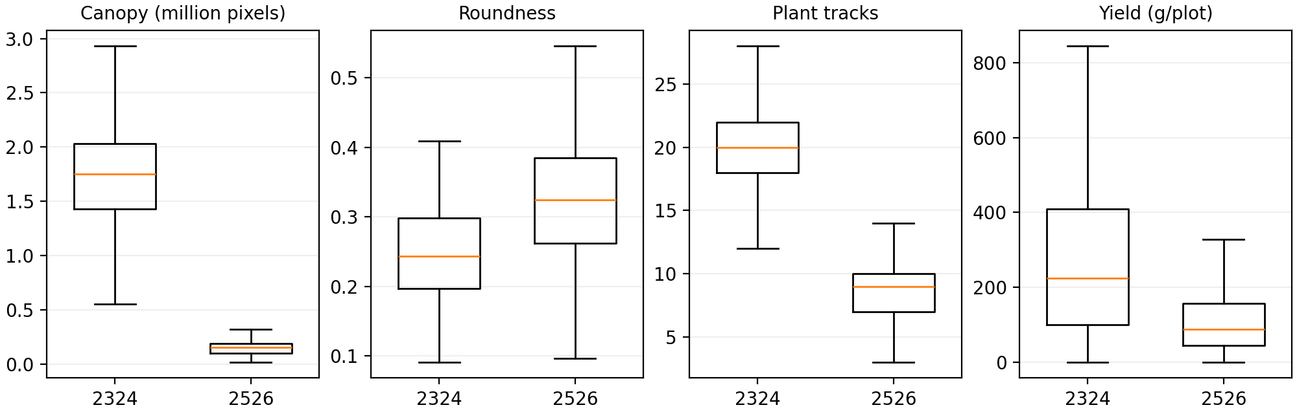
Note. Boxplots display observed distributions. Canopy uses millions of image pixels per plot, roundness is dimensionless, plant tracks are counts per plot, and yield is grams per plot per harvest. The boxes are descriptive, not prediction errors.
Season | Harvest records | Mean yield (g/plot) | Median yield (g/plot)
2324 | 320 | 264.6 | 223.5
2526 | 480 | 115.5 | 88.0
Note. Each harvest record is one plot on one harvest date. These values are per-plot harvest yield, not total seasonal production or yield per plant.
Observed harvest yield per plot was higher in 2324 than 2526 (264.6 vs 115.5 g/plot on average). The 2526 collection represented about half as many plants per plot, approximately 10 rather than 20, which is an important design reason for the lower raw plot yield. The canopy pixel difference is larger than the plant-number change alone and also reflects image scale and segmentation.
YOLO counted fewer FL, G, W and P than field counting on the matched plot-dates in both seasons. R was closer to manual counts: Pearson r was 0.73 in 2324 and 0.81 in 2526. Observed zero counts were retained as zeros.
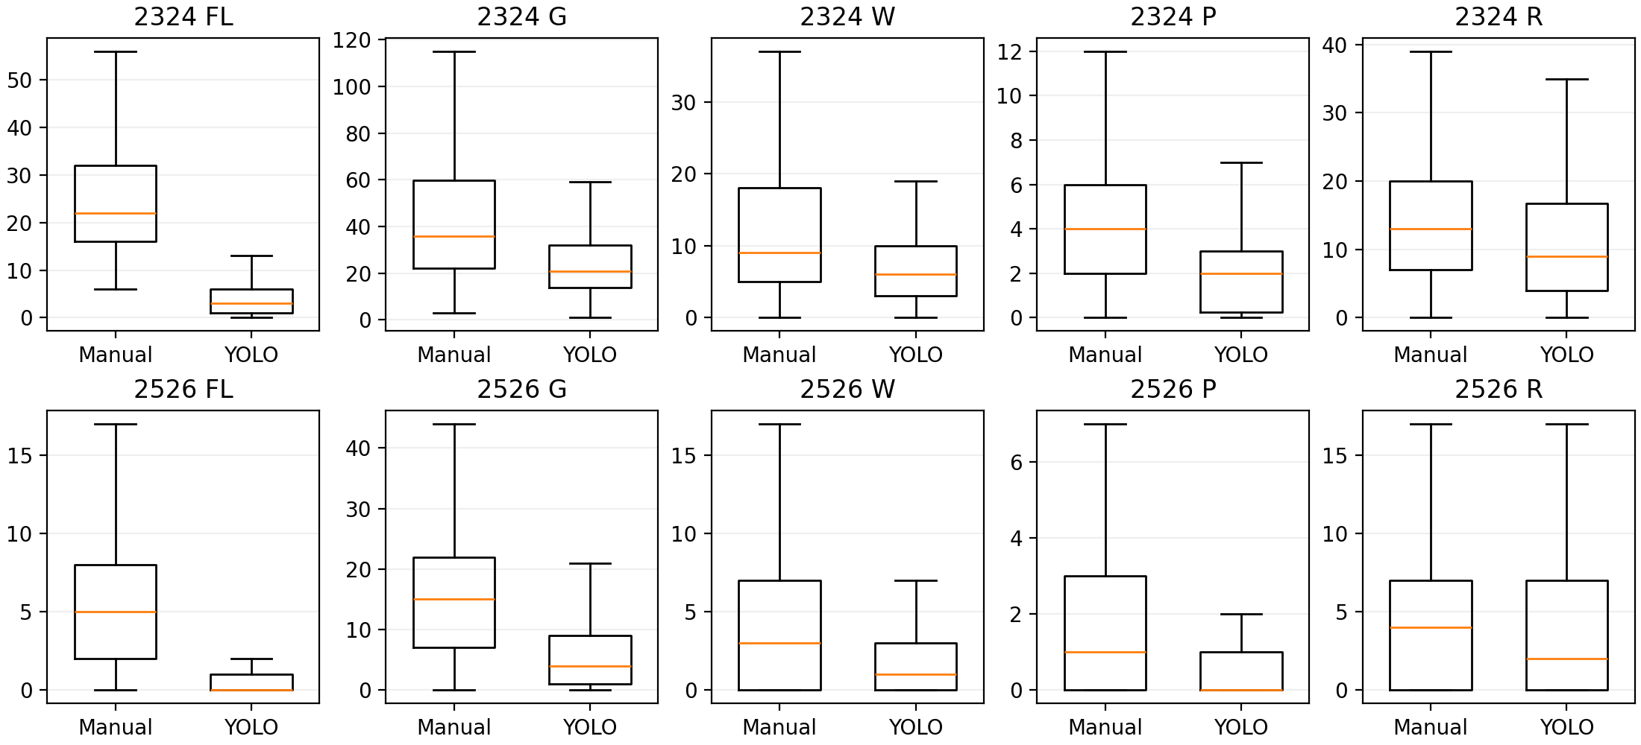
Note. Each boxplot uses counts per plot-date. Manual is field counting and YOLO is image-derived counting. R denotes mature red fruit and is descriptive only.
Season | Feature | Manual mean | YOLO mean | Pearson r
2324 | FL | 25.2 | 4.3 | 0.17
2324 | G | 42.7 | 24.8 | 0.39
2324 | W | 15.7 | 7.1 | 0.28
2324 | P | 4.8 | 2.2 | 0.12
2324 | R | 14.1 | 11.5 | 0.73
2526 | FL | 5.6 | 0.6 | 0.32
2526 | G | 15.6 | 5.7 | 0.52
2526 | W | 4.7 | 2.0 | 0.55
2526 | P | 2.2 | 0.6 | 0.46
2526 | R | 4.4 | 4.5 | 0.81
Note. Manual and YOLO means are counts per plot-date. Pearson r measures agreement across matched plot-dates, not correlation with yield.
Conclusion: Manual and YOLO counts are related but differ in scale, particularly for FL, G, W and P. Their forecasting results therefore require a matched comparison.

3. Association with observed harvest yield
Image features were paired with the observed harvest nearest 7, 14 or 21 days later (±2 days). At one week, canopy–yield Pearson r was 0.325 in 2324 and 0.139 in 2526. Roundness–yield r was −0.070 and −0.392. Manual W–yield r was 0.274 and 0.425, while YOLO W–yield r was 0.424 and 0.325. The figure shows only eligible prediction features at one week. Separate descriptive tables retain all recorded variables and three horizons.
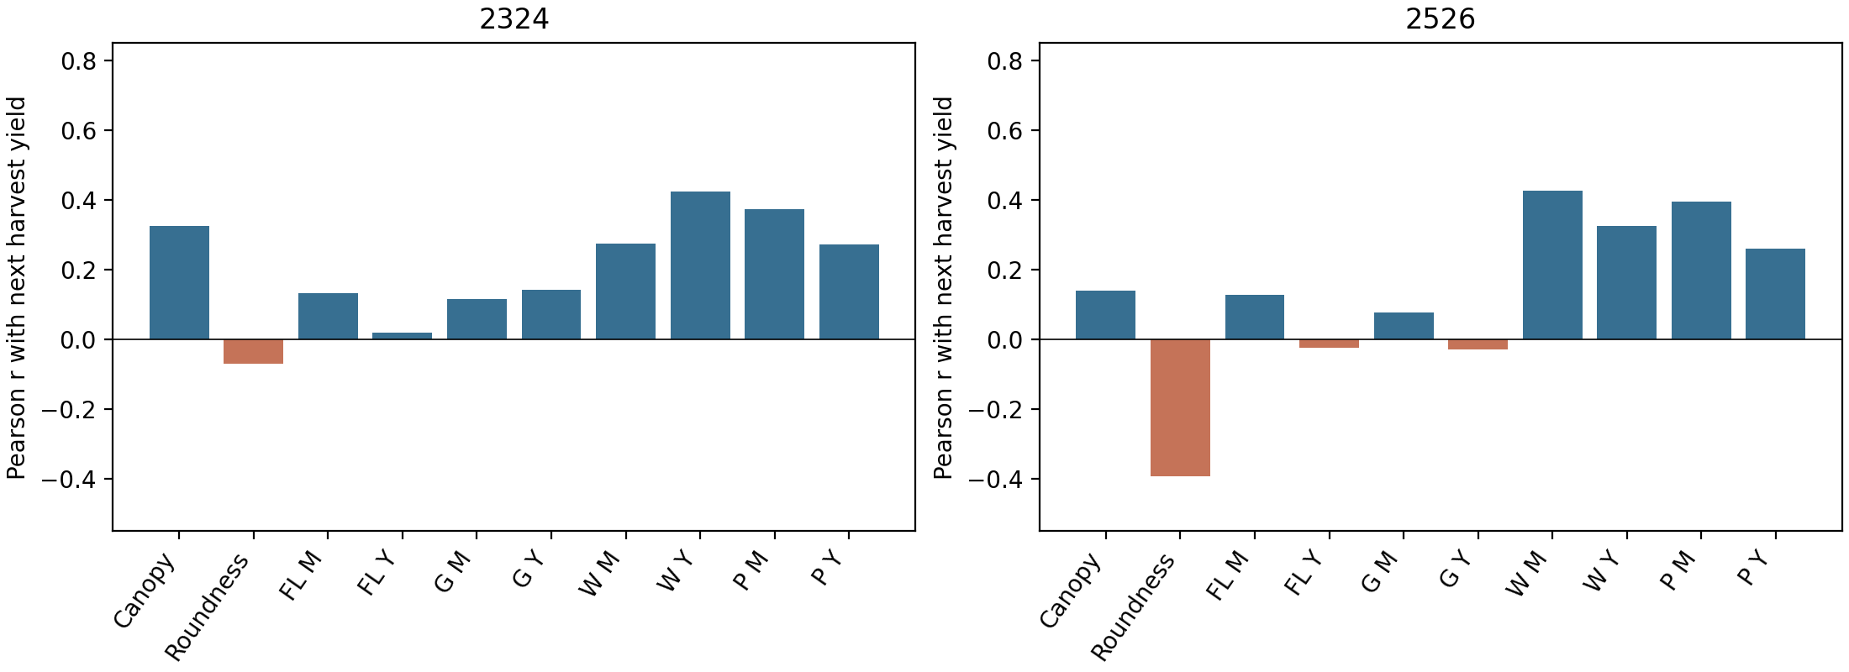
Note. Bar height is the one-week Pearson correlation with observed harvest yield. M and Y identify manual and YOLO count sources. R and retained plant tracks are not shown because they are not prediction features.
Conclusion: Association strength and direction vary between seasons and counting sources. These correlations do not establish causation or guarantee forecast accuracy.

4. Prediction design and overall results
The only prediction features are FL, G, W, P, canopy size and roundness. Retained plant tracks are used for image quality control and are not prediction inputs. The six input sets are canopy, roundness, FL/G/W/P, canopy with roundness, canopy with FL/G/W/P, and all six features. Twelve fixed predictive models cover linear and nonlinear regression, tree models, support vector regression and three neural sequence models. Current-input models use the latest image date. Temporal models use three available observations. Each result predicts one observed harvest yield in grams per plot, not total seasonal yield.
Manual and YOLO runs use identical plot-dates, harvest labels, test IDs and model settings. Cross-season results are reported in both directions. Within-season models are refitted chronologically using only harvest labels available before the forecast date. Two earlier completed harvests are required. The 2526 → 2324 transfer is retrospective. Lower MAE is better. All rankings are descriptive because the test results have been inspected.
The fixed random-forest comparison below isolates the six input choices at one week. Canopy-only and roundness-only values are identical between manual and YOLO, and their errors match exactly.
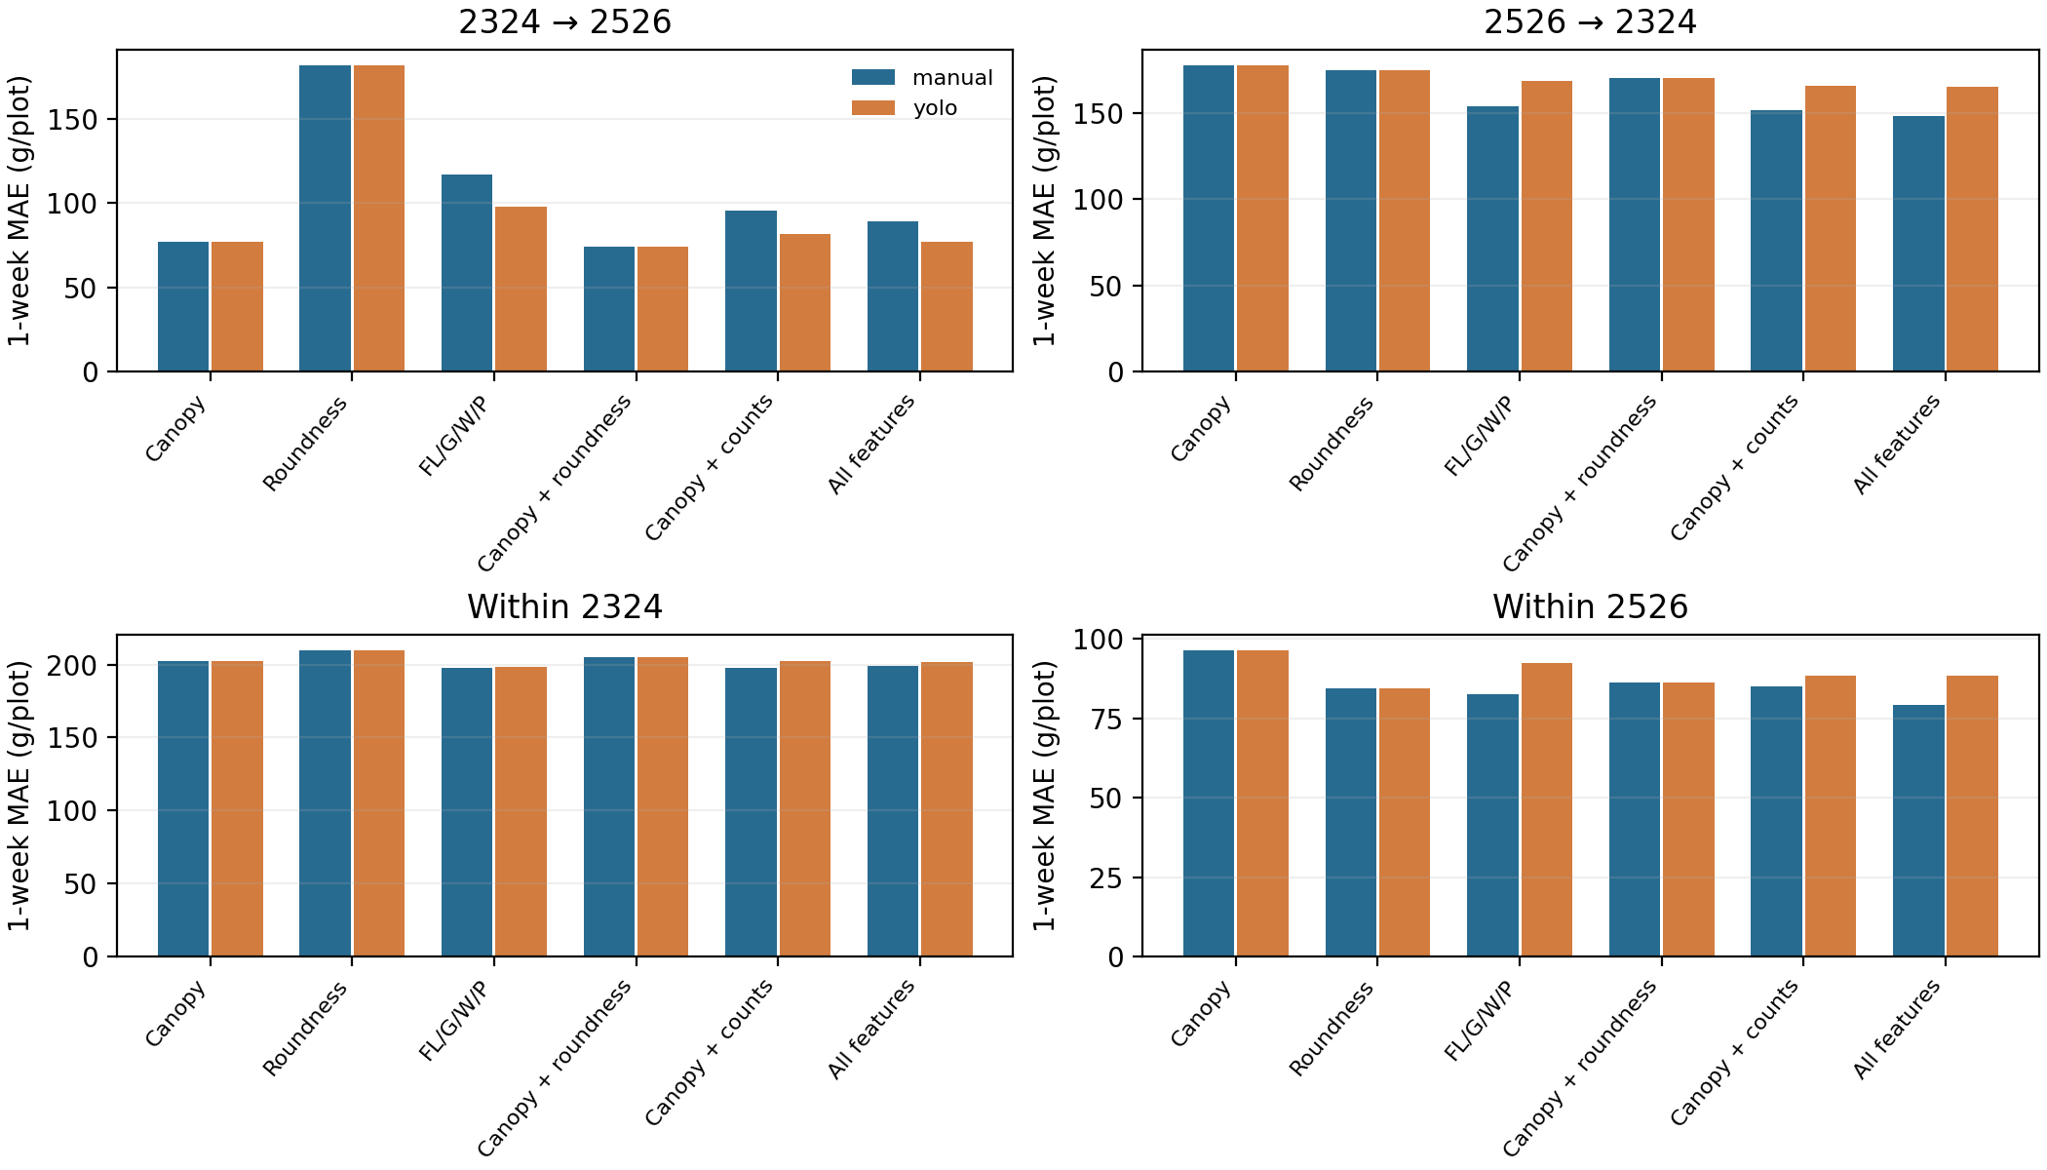
2324 → 2526: the lowest random-forest MAE among six input sets was Canopy + roundness with manual counts (73.8 g/plot), and Canopy + roundness with YOLO counts (73.8 g/plot).
2526 → 2324: the lowest random-forest MAE among six input sets was All features with manual counts (148.2 g/plot), and All features with YOLO counts (165.2 g/plot).
Within 2324: the lowest random-forest MAE among six input sets was Counts with manual counts (197.4 g/plot), and Counts with YOLO counts (198.6 g/plot).
Within 2526: the lowest random-forest MAE among six input sets was All features with manual counts (79.2 g/plot), and Roundness with YOLO counts (84.5 g/plot).
All 12 models are compared on the complete feature set in the following figure and tables.
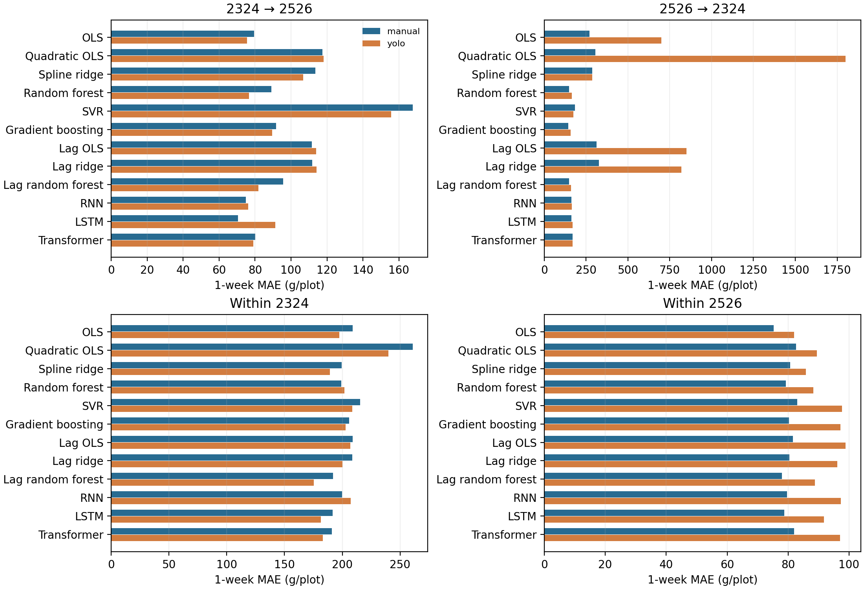
Note. Each paired value is manual / YOLO MAE in g/plot, with lower values indicating smaller prediction errors. For example, 89.0 / 76.7 for the one-week random forest means 89.0 using manual FL/G/W/P and 76.7 using YOLO FL/G/W/P. A dash means no eligible forecast.
1-week overall prediction: manual / YOLO MAE (g/plot)
Model | 2324 → 2526 | 2526 → 2324 | Within 2324 | Within 2526
OLS | 79.4 / 75.6 | 269.4 / 699.4 | 209.2 / 197.5 | 75.3 / 82.0
Quadratic OLS | 117.5 / 118.1 | 304.3 / 1801.2 | 260.9 / 239.9 | 82.6 / 89.5
Spline ridge | 113.5 / 106.9 | 286.5 / 287.4 | 199.5 / 189.2 | 80.6 / 85.8
Random forest | 89.0 / 76.7 | 148.2 / 165.2 | 199.0 / 202.0 | 79.2 / 88.3
SVR | 167.7 / 155.7 | 182.7 / 173.0 | 215.5 / 208.6 | 82.9 / 97.6
Gradient boosting | 91.6 / 89.6 | 143.5 / 157.0 | 205.9 / 202.8 | 80.3 / 97.2
Lag OLS | 111.5 / 113.9 | 311.5 / 850.2 | 208.9 / 206.8 | 81.6 / 98.9
Lag ridge | 111.7 / 114.3 | 327.5 / 819.3 | 208.6 / 200.0 | 80.4 / 96.1
Lag random forest | 95.5 / 81.8 | 149.1 / 159.3 | 192.1 / 175.3 | 77.9 / 88.7
RNN | 74.8 / 76.1 | 162.8 / 164.2 | 200.0 / 207.2 | 79.7 / 97.3
LSTM | 70.4 / 91.2 | 161.1 / 169.6 | 191.7 / 181.5 | 78.7 / 91.7
Transformer | 80.0 / 78.9 | 169.7 / 168.3 | 190.9 / 183.0 | 81.9 / 97.0
2324 → 2526, 1 week(s): lowest manual MAE was LSTM (70.4 g/plot). Lowest YOLO MAE was OLS (75.6 g/plot). Manual had lower MAE for 5 of 12 models and YOLO for 7.
2526 → 2324, 1 week(s): lowest manual MAE was Gradient boosting (143.5 g/plot). Lowest YOLO MAE was Gradient boosting (157.0 g/plot). Manual had lower MAE for 10 of 12 models and YOLO for 2.
Within 2324, 1 week(s): lowest manual MAE was Transformer (190.9 g/plot). Lowest YOLO MAE was Lag random forest (175.3 g/plot). Manual had lower MAE for 2 of 12 models and YOLO for 10.
Within 2526, 1 week(s): lowest manual MAE was OLS (75.3 g/plot). Lowest YOLO MAE was OLS (82.0 g/plot). Manual had lower MAE for 12 of 12 models and YOLO for 0.
2-week overall prediction: manual / YOLO MAE (g/plot)
Model | 2324 → 2526 | 2526 → 2324 | Within 2324 | Within 2526
OLS | 57.9 / 63.4 | 264.8 / 153.2 | 179.0 / 156.0 | 86.2 / 89.8
Quadratic OLS | 86.8 / 81.7 | 1377.6 / 319.0 | 186.6 / 215.6 | 103.2 / 92.0
Spline ridge | 207.6 / 201.6 | 223.4 / 152.7 | 116.0 / 111.2 | 85.8 / 88.7
Random forest | 118.7 / 107.7 | 191.9 / 173.8 | 107.7 / 107.3 | 86.4 / 89.8
SVR | 217.0 / 139.3 | 216.4 / 190.6 | 150.2 / 140.6 | 95.1 / 93.8
Gradient boosting | 112.5 / 96.9 | 172.6 / 169.2 | 121.8 / 128.9 | 85.5 / 87.3
Lag OLS | 75.2 / 81.6 | 155.3 / 195.3 | 160.9 / 158.7 | 85.4 / 95.5
Lag ridge | 75.9 / 82.4 | 150.0 / 213.5 | 160.8 / 144.5 | 82.5 / 93.3
Lag random forest | 114.5 / 101.8 | 185.9 / 169.2 | 107.7 / 106.6 | 83.6 / 84.9
RNN | 62.2 / 66.7 | 227.4 / 207.5 | 167.5 / 159.3 | 81.3 / 86.0
LSTM | 65.1 / 73.2 | 221.6 / 225.4 | 124.6 / 148.9 | 76.1 / 79.8
Transformer | 73.5 / 86.7 | 222.8 / 208.1 | 178.0 / 151.1 | 85.1 / 87.6
2324 → 2526, 2 week(s): lowest manual MAE was OLS (57.9 g/plot). Lowest YOLO MAE was OLS (63.4 g/plot). Manual had lower MAE for 6 of 12 models and YOLO for 6.
2526 → 2324, 2 week(s): lowest manual MAE was Lag ridge (150.0 g/plot). Lowest YOLO MAE was Spline ridge (152.7 g/plot). Manual had lower MAE for 3 of 12 models and YOLO for 9.
Within 2324, 2 week(s): lowest manual MAE was Lag random forest (107.7 g/plot). Lowest YOLO MAE was Lag random forest (106.6 g/plot). Manual had lower MAE for 3 of 12 models and YOLO for 9.
Within 2526, 2 week(s): lowest manual MAE was LSTM (76.1 g/plot). Lowest YOLO MAE was LSTM (79.8 g/plot). Manual had lower MAE for 10 of 12 models and YOLO for 2.
3-week overall prediction: manual / YOLO MAE (g/plot)
Model | 2324 → 2526 | 2526 → 2324 | Within 2324 | Within 2526
OLS | 87.5 / 76.9 | 169.9 / 160.5 | — | 87.4 / 109.0
Quadratic OLS | 102.9 / 125.3 | 4013.7 / 1205.3 | — | 98.5 / 130.3
Spline ridge | 205.9 / 224.6 | 294.5 / 236.4 | — | 83.4 / 88.4
Random forest | 116.7 / 116.9 | 157.3 / 188.3 | — | 84.1 / 90.5
SVR | 320.8 / 283.5 | 239.0 / 214.7 | — | 88.3 / 94.0
Gradient boosting | 90.2 / 121.7 | 151.4 / 198.9 | — | 87.5 / 97.5
Lag OLS | 107.4 / 102.4 | 380.8 / 883.2 | — | 85.7 / 104.0
Lag ridge | 106.6 / 103.9 | 374.0 / 858.4 | — | 81.7 / 99.7
Lag random forest | 106.7 / 106.3 | 162.3 / 166.2 | — | 82.1 / 85.9
RNN | 80.3 / 78.0 | 172.3 / 177.6 | — | 80.5 / 89.7
LSTM | 85.1 / 82.4 | 183.2 / 170.3 | — | 79.9 / 88.5
Transformer | 75.4 / 114.7 | 205.4 / 200.8 | — | 83.4 / 96.7
2324 → 2526, 3 week(s): lowest manual MAE was Transformer (75.4 g/plot). Lowest YOLO MAE was OLS (76.9 g/plot). Manual had lower MAE for 5 of 12 models and YOLO for 7.
2526 → 2324, 3 week(s): lowest manual MAE was Gradient boosting (151.4 g/plot). Lowest YOLO MAE was OLS (160.5 g/plot). Manual had lower MAE for 6 of 12 models and YOLO for 6.
Within 2324, 3 weeks: no chronological forecast met the two-prior-harvest requirement.
Within 2526, 3 week(s): lowest manual MAE was LSTM (79.9 g/plot). Lowest YOLO MAE was Lag random forest (85.9 g/plot). Manual had lower MAE for 12 of 12 models and YOLO for 0.
For the 396 overall model comparisons containing FL/G/W/P, manual had lower MAE in 221 and YOLO in 175. These are repeated evaluations on shared plots and harvest dates, not independent trials.
A fixed random forest illustrates the change with forecast lead time. Its results do not represent every model.
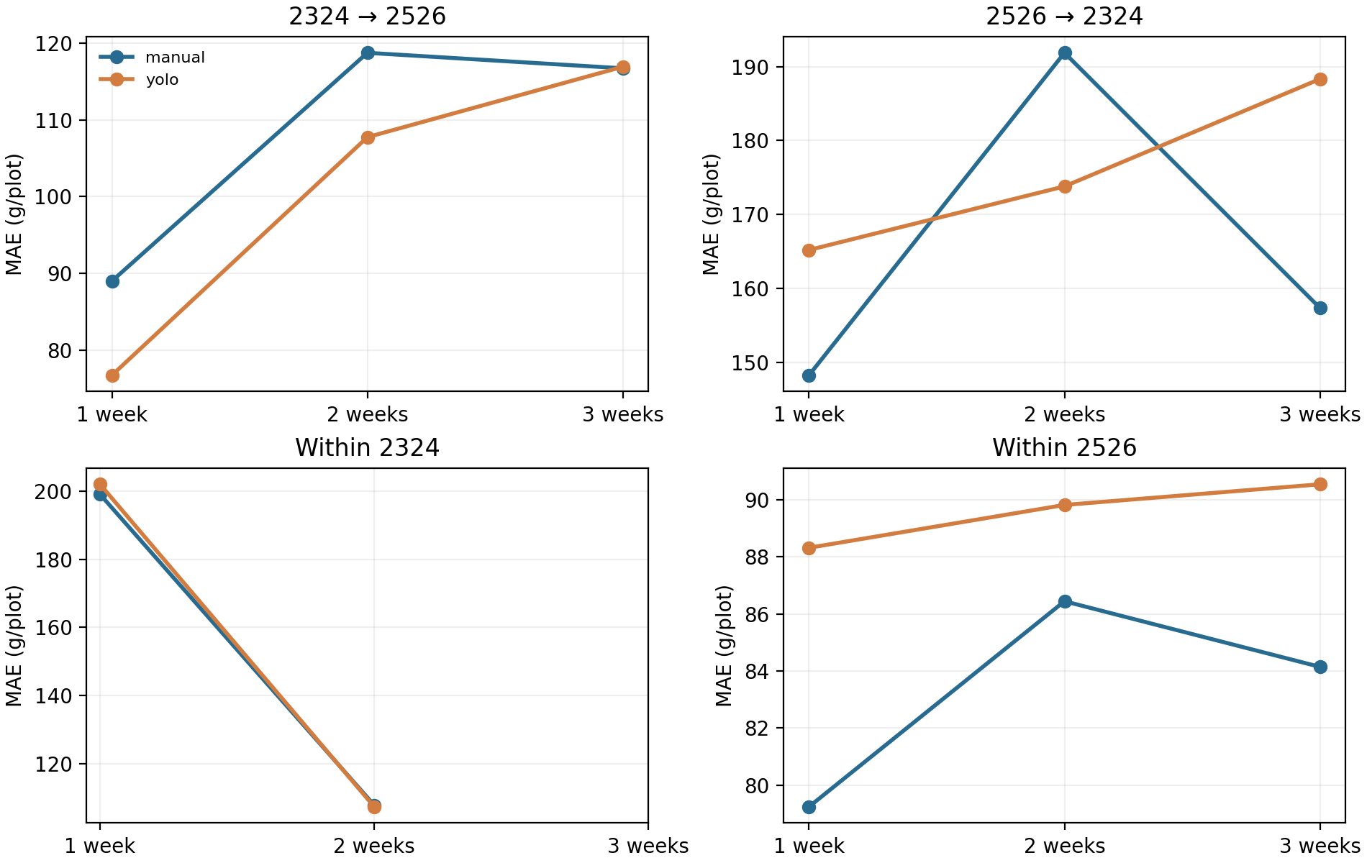

5. Early, middle and late harvest periods
Early, middle and late refer to ordered thirds of observed harvest dates within each season. These are calendar groups, not physiological stages. A phase with one harvest date has limited evidence. Tables below score each overall-fitted model separately by harvest period.
Note. M/Y means manual MAE first and YOLO MAE second, both in g/plot. Overall is the pooled-model result. Early, Middle and Late score that same model on the indicated harvest periods. A dash means no eligible chronological forecast.
2324 → 2526, 1 week(s): overall and harvest-period MAE
Model | Overall M/Y | Early M/Y | Middle M/Y | Late M/Y
OLS | 79.4 / 75.6 | 51.9 / 44.1 | 118.5 / 124.6 | 101.2 / 98.3
Quadratic OLS | 117.5 / 118.1 | 74.6 / 75.3 | 169.6 / 171.5 | 155.8 / 155.5
Spline ridge | 113.5 / 106.9 | 126.0 / 112.8 | 83.7 / 78.0 | 109.6 / 112.4
Random forest | 89.0 / 76.7 | 98.7 / 69.0 | 79.4 / 78.1 | 79.2 / 87.6
SVR | 167.7 / 155.7 | 207.7 / 162.6 | 110.1 / 145.6 | 136.4 / 150.4
Gradient boosting | 91.6 / 89.6 | 102.5 / 91.7 | 86.1 / 81.9 | 78.2 / 90.5
Lag OLS | 111.5 / 113.9 | 65.8 / 73.5 | 170.9 / 172.2 | 150.3 / 145.3
Lag ridge | 111.7 / 114.3 | 68.0 / 75.2 | 170.7 / 172.1 | 147.9 / 144.1
Lag random forest | 95.5 / 81.8 | 101.2 / 78.4 | 87.3 / 76.4 | 91.2 / 89.5
RNN | 74.8 / 76.1 | 63.7 / 51.9 | 94.1 / 118.4 | 82.0 / 91.2
LSTM | 70.4 / 91.2 | 45.2 / 57.2 | 106.9 / 150.2 | 90.1 / 112.7
Transformer | 80.0 / 78.9 | 77.1 / 73.2 | 86.0 / 83.3 | 81.5 / 85.4
2324 → 2526, 1 week(s): lowest observed phase MAEs were Early (n=120): manual LSTM (45.2 g/plot), YOLO OLS (44.1 g/plot). Middle (n=40): manual Random forest (79.4 g/plot), YOLO Lag random forest (76.4 g/plot). Late (n=80): manual Gradient boosting (78.2 g/plot), YOLO Transformer (85.4 g/plot). These phase winners are descriptive.
2526 → 2324, 1 week(s): overall and harvest-period MAE
Model | Overall M/Y | Early M/Y | Middle M/Y | Late M/Y
OLS | 269.4 / 699.4 | 336.7 / 841.7 | 163.9 / 652.5 | 362.4 / 628.2
Quadratic OLS | 304.3 / 1801.2 | 178.5 / 2492.2 | 331.4 / 1926.9 | 389.1 / 919.1
Spline ridge | 286.5 / 287.4 | 85.8 / 86.3 | 391.5 / 391.7 | 327.8 / 330.0
Random forest | 148.2 / 165.2 | 95.2 / 109.1 | 196.2 / 209.6 | 128.4 / 153.8
SVR | 182.7 / 173.0 | 85.6 / 110.3 | 245.7 / 220.6 | 184.0 / 163.3
Gradient boosting | 143.5 / 157.0 | 103.2 / 108.4 | 184.7 / 200.8 | 121.3 / 139.3
Lag OLS | 311.5 / 850.2 | 402.1 / 1006.4 | 203.1 / 787.0 | 385.6 / 790.0
Lag ridge | 327.5 / 819.3 | 427.5 / 975.5 | 214.6 / 754.3 | 398.8 / 761.6
Lag random forest | 149.1 / 159.3 | 117.2 / 153.9 | 185.4 / 185.5 | 125.9 / 124.9
RNN | 162.8 / 164.2 | 119.3 / 150.7 | 206.7 / 191.1 | 139.7 / 136.8
LSTM | 161.1 / 169.6 | 126.2 / 108.1 | 205.7 / 215.8 | 128.3 / 161.1
Transformer | 169.7 / 168.3 | 106.6 / 119.1 | 219.9 / 208.6 | 156.7 / 156.3
2526 → 2324, 1 week(s): lowest observed phase MAEs were Early (n=79): manual SVR (85.6 g/plot), YOLO Spline ridge (86.3 g/plot). Middle (n=120): manual OLS (163.9 g/plot), YOLO Lag random forest (185.5 g/plot). Late (n=79): manual Gradient boosting (121.3 g/plot), YOLO Lag random forest (124.9 g/plot). These phase winners are descriptive.
Within 2324, 1 week(s): overall and harvest-period MAE
Model | Overall M/Y | Early M/Y | Middle M/Y | Late M/Y
OLS | 209.2 / 197.5 | — | 279.7 / 273.0 | 137.7 / 121.0
Quadratic OLS | 260.9 / 239.9 | — | 280.3 / 245.4 | 241.2 / 234.4
Spline ridge | 199.5 / 189.2 | — | 279.2 / 273.3 | 118.7 / 103.9
Random forest | 199.0 / 202.0 | — | 277.3 / 274.5 | 119.7 / 128.6
SVR | 215.5 / 208.6 | — | 273.5 / 268.2 | 156.7 / 148.2
Gradient boosting | 205.9 / 202.8 | — | 282.0 / 269.6 | 128.8 / 135.2
Lag OLS | 208.9 / 206.8 | — | 255.7 / 279.5 | 161.5 / 133.2
Lag ridge | 208.6 / 200.0 | — | 262.7 / 272.6 | 153.8 / 126.6
Lag random forest | 192.1 / 175.3 | — | 269.1 / 237.6 | 114.1 / 112.3
RNN | 200.0 / 207.2 | — | 261.0 / 285.0 | 138.2 / 128.4
LSTM | 191.7 / 181.5 | — | 241.9 / 229.8 | 140.9 / 132.5
Transformer | 190.9 / 183.0 | — | 237.1 / 226.3 | 144.1 / 139.2
Within 2324, 1 week(s): lowest observed phase MAEs were Middle (n=80): manual Transformer (237.1 g/plot), YOLO Transformer (226.3 g/plot). Late (n=79): manual Lag random forest (114.1 g/plot), YOLO Spline ridge (103.9 g/plot). These phase winners are descriptive.
Within 2526, 1 week(s): overall and harvest-period MAE
Model | Overall M/Y | Early M/Y | Middle M/Y | Late M/Y
OLS | 75.3 / 82.0 | — | 91.6 / 96.8 | 67.1 / 74.6
Quadratic OLS | 82.6 / 89.5 | — | 92.5 / 109.8 | 77.6 / 79.3
Spline ridge | 80.6 / 85.8 | — | 95.5 / 98.2 | 73.2 / 79.7
Random forest | 79.2 / 88.3 | — | 92.8 / 101.9 | 72.5 / 81.5
SVR | 82.9 / 97.6 | — | 91.6 / 118.0 | 78.6 / 87.5
Gradient boosting | 80.3 / 97.2 | — | 91.2 / 102.2 | 74.9 / 94.6
Lag OLS | 81.6 / 98.9 | — | 110.1 / 108.4 | 67.3 / 94.1
Lag ridge | 80.4 / 96.1 | — | 107.5 / 107.6 | 66.9 / 90.4
Lag random forest | 77.9 / 88.7 | — | 93.3 / 105.0 | 70.2 / 80.6
RNN | 79.7 / 97.3 | — | 100.1 / 106.7 | 69.4 / 92.7
LSTM | 78.7 / 91.7 | — | 96.5 / 108.1 | 69.8 / 83.5
Transformer | 81.9 / 97.0 | — | 107.6 / 116.5 | 69.1 / 87.3
Within 2526, 1 week(s): lowest observed phase MAEs were Middle (n=40): manual Gradient boosting (91.2 g/plot), YOLO OLS (96.8 g/plot). Late (n=80): manual Lag ridge (66.9 g/plot), YOLO OLS (74.6 g/plot). These phase winners are descriptive.
2324 → 2526, 2 week(s): overall and harvest-period MAE
Model | Overall M/Y | Early M/Y | Middle M/Y | Late M/Y
OLS | 57.9 / 63.4 | 35.8 / 40.1 | 72.9 / 93.3 | 83.2 / 83.0
Quadratic OLS | 86.8 / 81.7 | 64.9 / 54.3 | 118.5 / 99.9 | 103.5 / 113.3
Spline ridge | 207.6 / 201.6 | 218.9 / 215.4 | 202.8 / 206.6 | 193.1 / 178.5
Random forest | 118.7 / 107.7 | 130.1 / 104.3 | 110.8 / 130.7 | 105.8 / 101.4
SVR | 217.0 / 139.3 | 224.0 / 155.5 | 186.3 / 109.4 | 222.0 / 130.2
Gradient boosting | 112.5 / 96.9 | 129.2 / 96.0 | 104.8 / 108.6 | 91.7 / 92.3
Lag OLS | 75.2 / 81.6 | 55.2 / 56.2 | 89.1 / 104.0 | 97.9 / 108.3
Lag ridge | 75.9 / 82.4 | 52.5 / 54.0 | 95.8 / 107.6 | 100.7 / 112.1
Lag random forest | 114.5 / 101.8 | 124.8 / 99.8 | 111.2 / 119.4 | 101.0 / 96.0
RNN | 62.2 / 66.7 | 55.6 / 54.2 | 71.5 / 88.4 | 67.2 / 74.6
LSTM | 65.1 / 73.2 | 55.6 / 48.2 | 82.2 / 99.7 | 70.8 / 97.1
Transformer | 73.5 / 86.7 | 70.3 / 81.4 | 76.1 / 96.6 | 77.0 / 89.6
2324 → 2526, 2 week(s): lowest observed phase MAEs were Early (n=119): manual OLS (35.8 g/plot), YOLO OLS (40.1 g/plot). Middle (n=40): manual RNN (71.5 g/plot), YOLO RNN (88.4 g/plot). Late (n=80): manual RNN (67.2 g/plot), YOLO RNN (74.6 g/plot). These phase winners are descriptive.
2526 → 2324, 2 week(s): overall and harvest-period MAE
Model | Overall M/Y | Early M/Y | Middle M/Y | Late M/Y
OLS | 264.8 / 153.2 | 64.6 / 120.8 | 354.3 / 189.4 | 231.7 / 115.6
Quadratic OLS | 1377.6 / 319.0 | 1773.1 / 70.9 | 1473.3 / 393.3 | 1037.5 / 332.5
Spline ridge | 223.4 / 152.7 | 69.0 / 173.0 | 270.7 / 160.1 | 230.3 / 131.6
Random forest | 191.9 / 173.8 | 61.0 / 72.0 | 251.2 / 224.4 | 169.0 / 149.4
SVR | 216.4 / 190.6 | 71.0 / 113.1 | 270.0 / 229.6 | 209.2 / 171.3
Gradient boosting | 172.6 / 169.2 | 76.4 / 76.9 | 227.5 / 224.6 | 138.9 / 133.0
Lag OLS | 155.3 / 195.3 | 202.7 / 337.3 | 159.1 / 151.7 | 125.8 / 189.1
Lag ridge | 150.0 / 213.5 | 223.0 / 369.1 | 147.2 / 164.8 | 117.8 / 208.1
Lag random forest | 185.9 / 169.2 | 91.4 / 91.3 | 231.7 / 213.5 | 165.1 / 142.3
RNN | 227.4 / 207.5 | 57.8 / 75.8 | 290.3 / 260.3 | 218.7 / 194.8
LSTM | 221.6 / 225.4 | 67.9 / 57.6 | 277.9 / 283.6 | 214.7 / 222.6
Transformer | 222.8 / 208.1 | 56.8 / 72.1 | 283.4 / 262.3 | 215.6 / 195.6
2526 → 2324, 2 week(s): lowest observed phase MAEs were Early (n=40): manual Transformer (56.8 g/plot), YOLO LSTM (57.6 g/plot). Middle (n=119): manual Lag ridge (147.2 g/plot), YOLO Lag OLS (151.7 g/plot). Late (n=80): manual Lag ridge (117.8 g/plot), YOLO OLS (115.6 g/plot). These phase winners are descriptive.
Within 2324, 2 week(s): overall and harvest-period MAE
Model | Overall M/Y | Early M/Y | Middle M/Y | Late M/Y
OLS | 179.0 / 156.0 | — | — | 179.0 / 156.0
Quadratic OLS | 186.6 / 215.6 | — | — | 186.6 / 215.6
Spline ridge | 116.0 / 111.2 | — | — | 116.0 / 111.2
Random forest | 107.7 / 107.3 | — | — | 107.7 / 107.3
SVR | 150.2 / 140.6 | — | — | 150.2 / 140.6
Gradient boosting | 121.8 / 128.9 | — | — | 121.8 / 128.9
Lag OLS | 160.9 / 158.7 | — | — | 160.9 / 158.7
Lag ridge | 160.8 / 144.5 | — | — | 160.8 / 144.5
Lag random forest | 107.7 / 106.6 | — | — | 107.7 / 106.6
RNN | 167.5 / 159.3 | — | — | 167.5 / 159.3
LSTM | 124.6 / 148.9 | — | — | 124.6 / 148.9
Transformer | 178.0 / 151.1 | — | — | 178.0 / 151.1
Within 2324, 2 week(s): lowest observed phase MAEs were Late (n=80): manual Lag random forest (107.7 g/plot), YOLO Lag random forest (106.6 g/plot). These phase winners are descriptive.
Within 2526, 2 week(s): overall and harvest-period MAE
Model | Overall M/Y | Early M/Y | Middle M/Y | Late M/Y
OLS | 86.2 / 89.8 | — | 83.1 / 80.5 | 87.7 / 94.5
Quadratic OLS | 103.2 / 92.0 | — | 92.2 / 90.2 | 108.7 / 92.9
Spline ridge | 85.8 / 88.7 | — | 84.0 / 81.0 | 86.6 / 92.6
Random forest | 86.4 / 89.8 | — | 86.8 / 79.0 | 86.3 / 95.2
SVR | 95.1 / 93.8 | — | 88.2 / 89.2 | 98.5 / 96.1
Gradient boosting | 85.5 / 87.3 | — | 85.6 / 74.0 | 85.5 / 94.0
Lag OLS | 85.4 / 95.5 | — | 86.5 / 82.2 | 84.9 / 102.2
Lag ridge | 82.5 / 93.3 | — | 84.0 / 81.2 | 81.7 / 99.3
Lag random forest | 83.6 / 84.9 | — | 84.5 / 79.1 | 83.1 / 87.9
RNN | 81.3 / 86.0 | — | 81.4 / 78.1 | 81.3 / 89.9
LSTM | 76.1 / 79.8 | — | 78.5 / 77.3 | 74.8 / 81.1
Transformer | 85.1 / 87.6 | — | 81.3 / 78.8 | 87.0 / 92.0
Within 2526, 2 week(s): lowest observed phase MAEs were Middle (n=40): manual LSTM (78.5 g/plot), YOLO Gradient boosting (74.0 g/plot). Late (n=80): manual LSTM (74.8 g/plot), YOLO LSTM (81.1 g/plot). These phase winners are descriptive.
2324 → 2526, 3 week(s): overall and harvest-period MAE
Model | Overall M/Y | Early M/Y | Middle M/Y | Late M/Y
OLS | 87.5 / 76.9 | 62.8 / 51.9 | 80.4 / 68.0 | 116.7 / 107.7
Quadratic OLS | 102.9 / 125.3 | 107.2 / 130.1 | 76.2 / 82.8 | 116.4 / 149.0
Spline ridge | 205.9 / 224.6 | 227.8 / 262.0 | 205.6 / 217.5 | 184.4 / 192.1
Random forest | 116.7 / 116.9 | 138.9 / 146.0 | 110.4 / 101.2 | 99.0 / 98.6
SVR | 320.8 / 283.5 | 358.6 / 349.8 | 353.1 / 273.4 | 261.9 / 224.5
Gradient boosting | 90.2 / 121.7 | 99.3 / 157.8 | 79.8 / 101.4 | 88.1 / 99.5
Lag OLS | 107.4 / 102.4 | 81.0 / 77.9 | 91.8 / 85.5 | 144.1 / 138.0
Lag ridge | 106.6 / 103.9 | 73.5 / 72.8 | 95.0 / 90.3 | 147.2 / 143.7
Lag random forest | 106.7 / 106.3 | 122.9 / 126.3 | 100.6 / 97.4 | 94.8 / 92.3
RNN | 80.3 / 78.0 | 72.2 / 79.1 | 60.0 / 58.7 | 101.8 / 89.9
LSTM | 85.1 / 82.4 | 57.6 / 89.6 | 80.1 / 55.9 | 115.7 / 92.9
Transformer | 75.4 / 114.7 | 65.1 / 139.8 | 59.3 / 98.9 | 96.5 / 100.5
2324 → 2526, 3 week(s): lowest observed phase MAEs were Early (n=119): manual LSTM (57.6 g/plot), YOLO OLS (51.9 g/plot). Middle (n=80): manual Transformer (59.3 g/plot), YOLO LSTM (55.9 g/plot). Late (n=120): manual Gradient boosting (88.1 g/plot), YOLO RNN (89.9 g/plot). These phase winners are descriptive.
2526 → 2324, 3 week(s): overall and harvest-period MAE
Model | Overall M/Y | Early M/Y | Middle M/Y | Late M/Y
OLS | 169.9 / 160.5 | — | 170.3 / 164.5 | 169.1 / 154.7
Quadratic OLS | 4013.7 / 1205.3 | — | 3979.9 / 1093.9 | 4063.9 / 1371.1
Spline ridge | 294.5 / 236.4 | — | 327.6 / 264.8 | 245.1 / 194.2
Random forest | 157.3 / 188.3 | — | 179.6 / 209.6 | 124.2 / 156.6
SVR | 239.0 / 214.7 | — | 263.1 / 238.6 | 203.1 / 179.2
Gradient boosting | 151.4 / 198.9 | — | 172.0 / 220.6 | 120.8 / 166.6
Lag OLS | 380.8 / 883.2 | — | 379.3 / 866.7 | 382.9 / 907.7
Lag ridge | 374.0 / 858.4 | — | 371.0 / 841.2 | 378.5 / 883.9
Lag random forest | 162.3 / 166.2 | — | 188.7 / 187.9 | 123.1 / 134.0
RNN | 172.3 / 177.6 | — | 193.2 / 197.8 | 141.2 / 147.7
LSTM | 183.2 / 170.3 | — | 206.3 / 191.3 | 148.9 / 139.2
Transformer | 205.4 / 200.8 | — | 229.6 / 223.4 | 169.4 / 167.3
2526 → 2324, 3 week(s): lowest observed phase MAEs were Middle (n=119): manual OLS (170.3 g/plot), YOLO OLS (164.5 g/plot). Late (n=80): manual Gradient boosting (120.8 g/plot), YOLO Lag random forest (134.0 g/plot). These phase winners are descriptive.
Within 2526, 3 week(s): overall and harvest-period MAE
Model | Overall M/Y | Early M/Y | Middle M/Y | Late M/Y
OLS | 87.4 / 109.0 | — | 67.3 / 77.7 | 100.8 / 129.8
Quadratic OLS | 98.5 / 130.3 | — | 74.1 / 113.7 | 114.9 / 141.3
Spline ridge | 83.4 / 88.4 | — | 59.7 / 59.0 | 99.2 / 108.0
Random forest | 84.1 / 90.5 | — | 68.0 / 67.1 | 94.9 / 106.2
SVR | 88.3 / 94.0 | — | 64.5 / 72.1 | 104.2 / 108.6
Gradient boosting | 87.5 / 97.5 | — | 73.7 / 70.6 | 96.7 / 115.4
Lag OLS | 85.7 / 104.0 | — | 77.2 / 84.0 | 91.4 / 117.4
Lag ridge | 81.7 / 99.7 | — | 69.4 / 77.5 | 89.9 / 114.5
Lag random forest | 82.1 / 85.9 | — | 63.8 / 63.3 | 94.4 / 100.9
RNN | 80.5 / 89.7 | — | 62.7 / 62.3 | 92.4 / 107.9
LSTM | 79.9 / 88.5 | — | 59.2 / 62.1 | 93.7 / 106.1
Transformer | 83.4 / 96.7 | — | 65.3 / 70.1 | 95.5 / 114.4
Within 2526, 3 week(s): lowest observed phase MAEs were Middle (n=80): manual LSTM (59.2 g/plot), YOLO Spline ridge (59.0 g/plot). Late (n=120): manual Lag ridge (89.9 g/plot), YOLO Lag random forest (100.9 g/plot). These phase winners are descriptive.

6. Phase-specific training
A separate experiment fitted transfer models using only training samples from the same harvest period. The comparison with overall-fitted models uses exactly the same test plots for each period. Within-season phase-specific fits had too few earlier completed harvest dates and are therefore unavailable.
Note. In each cell, M = manual and Y = YOLO. For each source, the value before / is the phase-specific model MAE and the value after / is the overall-fitted model MAE, both in g/plot. A dash means that no phase-specific fit was available.
2324 → 2526, 1 week(s): phase-fitted / overall-fitted MAE on matched test plots
Model | Early phase/overall | Middle phase/overall | Late phase/overall
OLS | M 81/52. Y 87/44 | M 73/118. Y 81/125 | M 88/101. Y 93/98
Quadratic OLS | M 89/75. Y 89/75 | M 104/170. Y 172/171 | M 159/156. Y 112/156
Spline ridge | M 50/126. Y 50/113 | M 166/84. Y 170/78 | M 157/110. Y 151/112
Random forest | M 51/99. Y 54/69 | M 119/79. Y 86/78 | M 126/79. Y 118/88
SVR | M 55/208. Y 68/163 | M 173/110. Y 265/146 | M 164/136. Y 135/150
Gradient boosting | M 55/102. Y 56/92 | M 105/86. Y 80/82 | M 146/78. Y 109/90
Lag OLS | M 82/66. Y 78/74 | M 158/171. Y 172/172 | M 148/150. Y 159/145
Lag ridge | M 83/68. Y 77/75 | M 156/171. Y 172/172 | M 111/148. Y 147/144
Lag random forest | M 51/101. Y 52/78 | M 105/87. Y 82/76 | M 90/91. Y 88/90
RNN | M 67/64. Y 74/52 | M 75/94. Y 106/118 | M 82/82. Y 86/91
LSTM | M 68/45. Y 72/57 | M 81/107. Y 118/150 | M 87/90. Y 90/113
Transformer | M 58/77. Y 67/73 | M 80/86. Y 80/83 | M 79/81. Y 88/85
2324 → 2526, 1 week(s): phase-specific fitting had lower MAE in manual 19/36, yolo 17/36 matched model-period comparisons. The result varies by period and model.
2324 → 2526, 2 week(s): phase-fitted / overall-fitted MAE on matched test plots
Model | Early phase/overall | Middle phase/overall | Late phase/overall
OLS | M 47/36. Y 41/40 | M 77/73. Y 88/93 | M 109/83. Y 119/83
Quadratic OLS | M 53/65. Y 75/54 | M 108/119. Y 119/100 | M 114/103. Y 137/113
Spline ridge | M 46/219. Y 44/215 | M 265/203. Y 264/207 | M 205/193. Y 200/178
Random forest | M 40/130. Y 39/104 | M 130/111. Y 132/131 | M 101/106. Y 101/101
SVR | M 43/224. Y 42/156 | M 255/186. Y 152/109 | M 160/222. Y 115/130
Gradient boosting | M 40/129. Y 41/96 | M 124/105. Y 111/109 | M 87/92. Y 98/92
Lag OLS | M 56/55. Y 54/56 | M 94/89. Y 129/104 | M 81/98. Y 136/108
Lag ridge | M 56/53. Y 53/54 | M 101/96. Y 128/108 | M 78/101. Y 131/112
Lag random forest | M 41/125. Y 39/100 | M 112/111. Y 114/119 | M 97/101. Y 95/96
RNN | M 46/56. Y 39/54 | M 64/72. Y 72/88 | M 73/67. Y 81/75
LSTM | M 44/56. Y 40/48 | M 66/82. Y 74/100 | M 72/71. Y 81/97
Transformer | M 42/70. Y 37/81 | M 63/76. Y 96/97 | M 88/77. Y 82/90
2324 → 2526, 2 week(s): phase-specific fitting had lower MAE in manual 19/36, yolo 20/36 matched model-period comparisons. The result varies by period and model.
2324 → 2526, 3 week(s): phase-fitted / overall-fitted MAE on matched test plots
Model | Early phase/overall | Middle phase/overall | Late phase/overall
OLS | — | M 93/80. Y 62/68 | M 90/117. Y 94/108
Quadratic OLS | — | M 85/76. Y 142/83 | M 138/116. Y 134/149
Spline ridge | — | M 258/206. Y 266/218 | M 156/184. Y 159/192
Random forest | — | M 126/110. Y 125/101 | M 100/99. Y 102/99
SVR | — | M 266/353. Y 261/273 | M 164/262. Y 177/224
Gradient boosting | — | M 80/80. Y 82/101 | M 98/88. Y 98/99
Lag OLS | — | M 88/92. Y 85/86 | M 99/144. Y 142/138
Lag ridge | — | M 95/95. Y 86/90 | M 93/147. Y 141/144
Lag random forest | — | M 106/101. Y 121/97 | M 105/95. Y 93/92
RNN | — | M 58/60. Y 56/59 | M 96/102. Y 98/90
LSTM | — | M 66/80. Y 68/56 | M 84/116. Y 113/93
Transformer | — | M 59/59. Y 131/99 | M 111/96. Y 90/100
2324 → 2526, 3 week(s): phase-specific fitting had lower MAE in manual 12/24, yolo 13/24 matched model-period comparisons. The result varies by period and model.
2526 → 2324, 1 week(s): phase-fitted / overall-fitted MAE on matched test plots
Model | Early phase/overall | Middle phase/overall | Late phase/overall
OLS | M 270/337. Y 304/842 | M 341/164. Y 1237/653 | M 1090/362. Y 1600/628
Quadratic OLS | M 2752/179. Y 4384/2492 | M 392/331. Y 46775/1927 | M 13265/389. Y 520/919
Spline ridge | M 86/86. Y 86/86 | M 387/392. Y 391/392 | M 330/328. Y 330/330
Random forest | M 58/95. Y 68/109 | M 200/196. Y 198/210 | M 120/128. Y 132/154
SVR | M 59/86. Y 64/110 | M 244/246. Y 213/221 | M 153/184. Y 134/163
Gradient boosting | M 78/103. Y 77/108 | M 166/185. Y 179/201 | M 118/121. Y 131/139
Lag OLS | M 307/402. Y 297/1006 | M 448/203. Y 2314/787 | M 891/386. Y 577/790
Lag ridge | M 338/428. Y 316/976 | M 809/215. Y 1786/754 | M 830/399. Y 728/762
Lag random forest | M 60/117. Y 67/154 | M 196/185. Y 191/185 | M 122/126. Y 124/125
RNN | M 90/119. Y 92/151 | M 236/207. Y 163/191 | M 131/140. Y 134/137
LSTM | M 104/126. Y 111/108 | M 163/206. Y 169/216 | M 153/128. Y 124/161
Transformer | M 87/107. Y 68/119 | M 215/220. Y 210/209 | M 134/157. Y 138/156
2526 → 2324, 1 week(s): phase-specific fitting had lower MAE in manual 21/36, yolo 25/36 matched model-period comparisons. The result varies by period and model.
2526 → 2324, 2 week(s): phase-fitted / overall-fitted MAE on matched test plots
Model | Early phase/overall | Middle phase/overall | Late phase/overall
OLS | M 205/65. Y 160/121 | M 3108/354. Y 1334/189 | M 291/232. Y 945/116
Quadratic OLS | M 1278/1773. Y 95/71 | M 393/1473. Y 107483/393 | M 332/1038. Y 332/332
Spline ridge | M 69/69. Y 68/173 | M 393/271. Y 393/160 | M 141/230. Y 327/132
Random forest | M 44/61. Y 40/72 | M 210/251. Y 211/224 | M 149/169. Y 158/149
SVR | M 38/71. Y 41/113 | M 274/270. Y 270/230 | M 197/209. Y 159/171
Gradient boosting | M 53/76. Y 37/77 | M 182/228. Y 187/225 | M 149/139. Y 153/133
Lag OLS | M 199/203. Y 170/337 | M 3137/159. Y 1834/152 | M 332/126. Y 332/189
Lag ridge | M 264/223. Y 214/369 | M 2430/147. Y 1878/165 | M 332/118. Y 332/208
Lag random forest | M 50/91. Y 42/91 | M 209/232. Y 208/213 | M 146/165. Y 153/142
RNN | M 62/58. Y 51/76 | M 164/290. Y 205/260 | M 202/219. Y 190/195
LSTM | M 77/68. Y 77/58 | M 159/278. Y 173/284 | M 230/215. Y 223/223
Transformer | M 54/57. Y 49/72 | M 164/283. Y 167/262 | M 183/216. Y 150/196
2526 → 2324, 2 week(s): phase-specific fitting had lower MAE in manual 22/36, yolo 18/36 matched model-period comparisons. The result varies by period and model.
2526 → 2324, 3 week(s): phase-fitted / overall-fitted MAE on matched test plots
Model | Early phase/overall | Middle phase/overall | Late phase/overall
OLS | — | M 652/170. Y 1162/164 | M 305/169. Y 257/155
Quadratic OLS | — | M 10370/3980. Y 455/1094 | M 5757/4064. Y 577/1371
Spline ridge | — | M 393/328. Y 393/265 | M 129/245. Y 254/194
Random forest | — | M 215/180. Y 216/210 | M 110/124. Y 134/157
SVR | — | M 296/263. Y 271/239 | M 141/203. Y 153/179
Gradient boosting | — | M 179/172. Y 206/221 | M 113/121. Y 128/167
Lag OLS | — | M 1170/379. Y 1361/867 | M 895/383. Y 596/908
Lag ridge | — | M 1022/371. Y 1176/841 | M 793/378. Y 723/884
Lag random forest | — | M 220/189. Y 218/188 | M 113/123. Y 121/134
RNN | — | M 173/193. Y 174/198 | M 157/141. Y 171/148
LSTM | — | M 160/206. Y 189/191 | M 143/149. Y 127/139
Transformer | — | M 196/230. Y 200/223 | M 153/169. Y 145/167
2526 → 2324, 3 week(s): phase-specific fitting had lower MAE in manual 10/24, yolo 14/24 matched model-period comparisons. The result varies by period and model.

7. Model selection and interpretation
Selected model: Lag random forest with all six features. It had the lowest average MAE rank among the 72 model–input combinations across 11 available setting–horizon combinations and both count sources (13.77 out of 72). Each setting contributes one manual rank and one YOLO rank. This is a descriptive selection from the present data. The model did not have the lowest error in every individual evaluation.
One-week evaluation | Manual MAE | YOLO MAE | Matched plots
2324 → 2526 | 95.5 | 81.8 | 240
2526 → 2324 | 149.1 | 159.3 | 278
Within 2324 | 192.1 | 175.3 | 159
Within 2526 | 77.9 | 88.7 | 120
Note. Rank 1 denotes the lowest MAE among 72 model–input combinations in one setting. The table shows the selected model with all six features at a one-week lead time. Each MAE is in g/plot, and manual and YOLO use the same matched test plots in each row.
The earlier PheMuT system combined two YOLO detectors, ByteTrack, SAM, depth, weather encoding, stage weighting and an LSTM. The present prediction step uses FL, G, W, P, canopy and roundness. Canopy pixel scale differs substantially between seasons, and manual and YOLO counts disagree. The small number of distinct harvest dates limits the precision of model comparisons.

